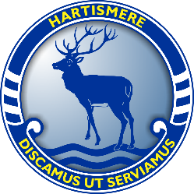

Hartismere School: Pre A Level Physical Education Work

Assessment
- 2 Exams (2 hours each, 105 marks each, 35% per paper)
- Non Exam Assessment (Coursework)- 90 Marks, 30% of A-Level.

Recommended Resources:
In preparation for your study on the course, we recommend that you purchase an A Level PE textbook to help you improve your knowledge alongside your studies. These will be referred to during your PE lessons next year:

AQA A Level PE (Year 1 and 2- Year 12 and 13 Content)
https://www.hoddereducation.co.uk/subjects/sport-pe/products/16-18/aqa-a-level-pe-(year-1-and-year-2)


AQA A Level PE Student Guide 1 (Paper 1)
https://www.hoddereducation.co.uk/subjects/sport-pe/products/a-level-(1)/aqa-a-level-physical-education-student-guide-1-fa


AQA A Level PE Student Guide 2 (Paper 2)
https://www.hoddereducation.co.uk/subjects/sport-pe/products/a-level-(1)/aqa-a-level-physical-education-student-guide-2-fa

AQA A Level PE Book 1 (Year 12)

https://www.aqa.org.uk/subjects/physical-education/a-level-physical-education-textbooks-print-and-digital

AQA A Level PE Book 2 (Year 13)
https://www.aqa.org.uk/subjects/physical-education/a-level-physical-education-textbooks-print-and-digital

Task 1: Preparation for Coursework
Please complete all tasks electronically and print in preparation for your first lesson:
Name:
Sport:
Role in Sport:
Refer to pages 42-101 on the specification link to find your chosen sport and read the list of core/advanced skills for Area of Assessment 1, 2 & 3: https://filestore.aqa.org.uk/resources/pe/specifications/AQA-7582-SP-2016.PDF
Using the table, consider a recent sporting performance that you took part in and analyse your strengths/weaknesses in relation to two of the core/advanced skills listed on the specification criteria. This should occur in relation to all three assessment areas:

- Area of Assessment 1 (Attacking Skills or Event 1)
- Area of Assessment 2 (Defensive Skills or Event 2)
- Area of Assessment 3 (Tactics and Strategies)
Areas of Assessment | Strengths | Areas for Development
Area of Assessment 1 (AA1):

Area of Assessment 2 (AA2):

Area of Assessment 3 (AA3):

Task 2: Anatomy and Physiology: Musculoskeletal System
In preparation for your first topic (Anatomy and Physiology- Musculoskeletal System), complete the following:
Define each Joint Movement:
Joint Movement | Definition
Flexion
Extension
Abduction
Adduction
Dorsi-Flexion
Plantar-Flexion
Rotation
Horizontal Abduction
Horizontal Adduction

Add the Joint Types, Articulating Bones, Types of Joint Movement (From the table above only) and the Agonist/Antagonist Muscles- Spend some time researching this online:
 | Joint Type | Articulating Bones | Joint Movements | Agonist Muscle (Contracting) | Antagonist Muscle (Relaxing)
Shoulder |  |  | Flexion
Shoulder |  |  | Extension/Hyper-Extension
Shoulder |  |  | Abduction
Shoulder |  |  | Adduction
Shoulder |  |  | Horizontal Adduction
Shoulder |  |  | Horizontal Abduction
Elbow |  |  | Flexion
Elbow |  |  | Extension
Hip |  |  | Flexion
Hip |  |  | Extension/Hyper-Extension
Hip |  |  | Abduction
Hip |  |  | Adduction
Hip |  |  | Horizontal Abduction
Hip |  |  | Horizontal Adduction
Knee |  |  | Flexion
Knee |  |  | Extension
Ankle |  |  | Plantar-Flexion
Ankle |  |  | Dorsi-Extension

Apply your knowledge to Sporting Examples: Complete the boxes based on what is seen in the picture:
Squat (Downward Phase):

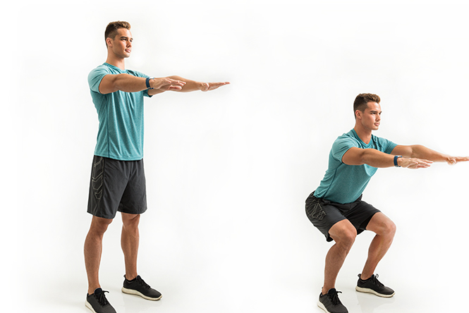

Joint | Knee | Hip
Joint Type
Articulating Bones
Joint Movement
Agonist
Antagonist

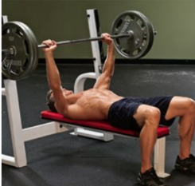
Bench Press Upward Phase

Joint | Elbow | Shoulder
Joint Type
Articulating Bones
Joint Movement
Agonist
Antagonist

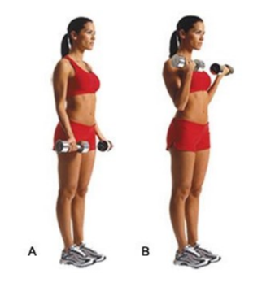
Bicep Curl: Upward Phase

Joint | Elbow
Joint Type
Articulating Bones
Joint Movement
Agonist
Antagonist

